CHAPTER 1
INTRODUCTION
  - Overview
Decision making has been a part of human life since the beginning. Methods used for making a decision vary from coin tossing to complex mathematical algorithms. Depending upon what is best suited for a particular type of decision making problem, a way is chosen. For complicated cases, with a number of criteria pertaining to different streams of knowledge, when experts with proficiency in one field may not be able to give due weight to others’ fields that do not come under their area of work, decision making can be a tough task. Since its formation by Saaty, Analytic hierarchy process (AHP) is widely used in multi criteria decision making due to its various advantages.
In this stiff competition for market leadership, optimized product development plan always plays a vital role. For the selection of best technology from a number of available technologies is important to achieve the goal. AHP is becoming popular and is seen to be use for a variety of decision problems ranging from finding out the best software to choosing best location for bridge.
Matrix algebra involved in AHP makes it time consuming. It is also possible that many decision makers may not know the matrix algebra altogether. To use a computer for doing these calculations is a wise solution. Numerical Software packages available in the market include Matlab, Mathematica, Maple, Gauss, Scilab, etc. Out of the listed packages, except for Scilab, all other packages are paid software. According to a comparative study on 7 numerical software, Mathematica and Matlab perform very well, whereas Scilab is worst [1]. Out of the available two numerical software available namely Matlab and Scilab, as Matlab outperforms Scilab in Speed, data handling, programming environment functionality, graphical functionality, installation, learnability and usability. After a futile attempt to make a package in Scilab, a more successful attempt to do it Matlab was made. A Matlab package has to be installed to use this package. To reduce the difficulty associated with this, a web application is made which can be used by anyone using internet and a web browser. There will be no need for installing any software to use this package. Java, one of the world’s most famous and widely used technology for web based applications is used to prepare this package.

  - Objective
This project is aimed at implementing AHP in a user friendly software package for ranking of alternative technologies.

  - Motivation
The motivation for this project was to reduce time for calculations. User friendly software would even allow a person to use AHP without knowing anything about matrix algebra. Current software that are available on web today include paid as well as free software by few companies, Helsinki University of Technology [2], Senshu University [3], Canadian Conservation Institute [4], University of Illinois, Chicago [5] and so on. Most of this software use single level of criteria in hierarchy tree and use less useful methods for calculating weights.

  - Overview of report
Chapter Two has detailed description of AHP, its maths, its various components and step by step working.
Chapter Three includes review of earlier codes and basics of the software used
Chapter Four has results, a solved example, and explanation of pseudo code.
Chapter Five is of conclusion, future work

CHAPTER-2
ANALYTIC HIERARCHY PROCESS
  - Introduction:
Decision making is an important function in any field of activity. From industry to government sector to agriculture, decision making is required. Sometimes the decision alternatives can be evaluated on the basis of a purely quantitative method i.e. decision is based on the numerical value of an objective function e.g. the linear programming methods are applied for many decision scenarios where the objective is to maximize or minimize an objective function. But in many real life problems decision is based on both quantitative and qualitative factors.
Decision making is the process to choose among alternatives based on multiple criteria. In each of these decisions, there are several factors or criteria and there are several alternatives choices that should be decided upon. Table 2.1 below shows example of criteria and alternatives of several decision makings. So, we can see that the decisions in Table 2.1 are based on some quantitative factors and some qualitative factors.

Table 2.1: Example of Goal, Criteria and Alternatives [6]
Goal | Criteria | Alternatives
Decide best school | - Distance,  - Reputation,  - Cost,  - Teacher kindliness | Name of schools under consideration
Finding best apartment | - Price,  - Down payment,  - Distance from shops,  - Distance from work/school  - Neighbor's Friendliness | List of apartments under consideration
Select best politician | - Charm  - Good working program  - Benefit for our organization  - Attention to our need | List of candidates
Determine thesis topic | - Fast to finish,  - Research Cost  - Level of Attractiveness, | List of thesis topics
Buy car | - Initial Price  - Operating & Maintenance cost  - Service and comfort  - Status | Car's trade mark (Honda, GM, Ford, Nissan etc.)
Decide whether to buy or to rent a machine | - Total cost (capital, maintenance, operational)  - Service  - Time to operate  - Interconnection with other machines | Rent or buy

For such multi criteria decision making instances Analytical Hierarchy Process (AHP) has been developed. The AHP is perhaps, the most widely used decision making approach in the world today. Its validity is based on the many hundreds (now thousands) of actual applications in which the AHP results were accepted and used by the cognizant decision makers [7].
Analytic Hierarchy Process (AHP) is one of Multi Criteria decision making methods that were originally developed by Prof. Thomas L. Saaty in the 1970s. The strength of AHP approach lies in its ability to structure a complex, multi-attribute, multiperson and multi-period problem hierarchically. In addition, it can also handle both qualitative (through representing qualitative attributes in terms of quantitative values) and quantitative attributes.

In short, AHP is a method to derive ratio scales from paired comparisons. The input can be obtained from actual measurement such as price, weight etc., or from subjective opinion such as satisfaction feelings and preference. The ratio scales are derived from the principal Eigen vectors and the consistency index is derived from the principal Eigen value.
AHP consists of four stages of problem solving:
- Decomposition of decision problem
- Comparative judgments
- Synthesis of priorities
- Calculation of Rank
AHP first decomposes the decision problem into a hierarchy of more easily comprehended sub-problems, each of which can be analyzed independently. The elements of the hierarchy can relate to any aspect of the decision problem—tangible or intangible, carefully measured or roughly estimated, well- or poorly-understood—anything at all that applies to the decision at hand.
Once the hierarchy is built, AHP systematically evaluates its various elements by comparing them to one another two at a time [8]. In making the comparisons, the decision makers can use concrete data about the elements, or they can use their judgments about the elements' relative meaning and importance.
The AHP converts these evaluations to numerical values that can be processed and compared over the entire range of the problem. A numerical weight or priority is derived for each element of the hierarchy, allowing diverse and often incommensurable elements to be compared to one another in a rational and consistent way. This capability distinguishes the AHP from other decision making techniques.
In the final step of the process, numerical priorities are calculated for each of the decision alternatives. These numbers represent the alternatives' relative ability to achieve the decision goal, so they allow a straightforward consideration of the various courses of action.
In the next section we will see how the AHP methodology functions.

  - Working of AHP
The AHP input consists of relative importance of criteria, preference on each criterion for each decision alternative and construction of pair wise comparison matrix using the above two inputs. The output consists of prioritised ranking indicating the overall preference for each decision alternative. The AHP consists of the following steps:
- Identify the overall goal.
- Identify the sub goals of the overall goal. If relevant identify the time horizon.
- Identify the criteria that must be satisfied to fulfil the sub goals of the overall goal.
- Identify sub-criteria under each criterion.
- Identify the stakeholders and their goals.
- Identify options and outcomes
- For yes-no decisions, take the most preferred outcome and compare the benefits and costs.
- Construct a pair wise comparison matrix of the relative contribution on each criteria.
- Obtain overall ranking of each decision alternative.
- Evaluation of consistency.

It was discussed in the previous section that AHP consists of 4 9, namely building hierarchy, pair wise comparisons, and synthesis of priorities and assignment of Ranks. In this section the working of AHP will be discussed phase by phase.

  - Building hierarchy:
The most important task in making a decision is to identify the factors (attributes) that are most appropriate to show the structural dependence of the problem. In AHP these factors are arranged, one selected in a hierarchic structure descending from an overall goal or objective or focus to criteria (attributes), sub-criteria (sub-attributes) and alternatives in successive levels. Arranging the goals, attributes, issues in a hierarchy serves two purposes.

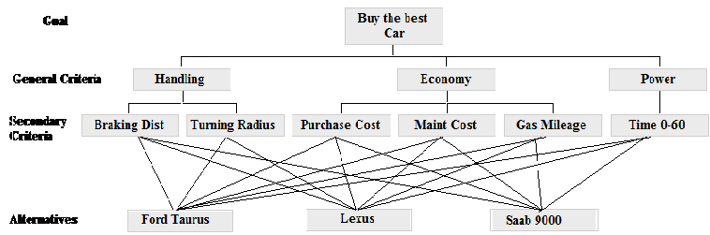
Fig. 2.1: Decision Hierarchy structure for buying a car [9]

It provides an overall view of the complex relationship inherent in the situation (cause-effect relations). This helps decision maker assess whether the issues in each level are of the same order of magnitude, so he can compare such homogeneous elements accurately. For example for the decision of buying a car the hierarchy structure can be expressed as in figure 2.1.
  - Pairwise Comparisons:
In any decision scenario several factors influence the decision. But the influence of these factors is not the same always. Some factor may be more important and other may not be so much important. AHP compares the relative importance of all factors by using pairwise comparisons. For qualitative factors, AHP uses a 9 point scale which assigns the relative importance of one factor over the other. We list this point scale in Table 2.2 as follows:
Table 2.2: 9 point scale for pair wise comparisons
Intensity of Importance | Definition
1 | Equal importance
3 | Weak importance of one over other
5 | Strong Importance
7 | Demonstrated Importance
9 | Absolute Importance
2,4,6,8 | Intermediate Values
Reciprocals of the above | If activity i has one of the above numbers assigned to it when compared with activity j, then j has the reciprocal value when compared with i.
1.1 – 1.9 | When elements are close and nearly indistinguishable

For quantitative factors we need not make any comparison matrix. For example pair wise comparisons of 3 fruits apple, banana and cherry can be considered according to the subjective judgements of a person, John [6].
 | 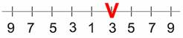 | 
 | 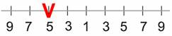 | 
 | 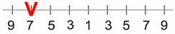
Fig 2.2: Pair wise comparisons between 3 fruits
A matrix can be made from the 3 comparisons above. Because we have three comparisons, thus we have 3 by 3 matrix. The diagonal elements of the matrix are always 1 and only the upper triangular matrix needs to be filled. The following rules are used to fill the matrix:

- If the judgment value is on the left side of 1, we put the actual judgment value.
- If the judgment value is on the right side of 1, we put the reciprocal value.

Comparing apple and banana, John slightly favor banana, thus 1/3 is put in the row 1 column 2 of the matrix. Comparing Apple and Cherry, John strongly likes apple, thus actual judgment 5 is put on the first row, last column of the matrix. Comparing banana and cherry, banana is dominant. Thus his actual judgment is put on the second row, last column of the matrix. Then based on his preference values above, we have a reciprocal matrix like this
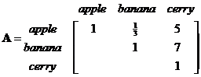
To fill the lower triangular matrix, we use the reciprocal values of the upper diagonal. If is the element of ith row jth column of the matrix, then the lower diagonal is filled using this formula
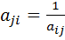......................................................(2.1)
Thus now we have complete comparison matrix.
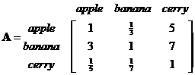
Notice that all the elements in the comparison matrix are positive, or .

In AHP comparisons matrices are formed:
- For all sub criteria within a criterion.
- Amongst the top level criteria and
- For the various alternatives with respect to each qualitative leaf node (a node without any successors) of the hierarchy tree.

This helps in understanding the relative importance of any criteria with respect to any other criteria and also the relative importance of the sub criteria within a criterion. Also we get the competitiveness of the alternatives with respect to the alternatives.

  - Synthesis of Priorities and Value Table for Alternatives:
Priorities are numbers associated with the nodes of an AHP hierarchy. They represent the relative weights of the nodes in any group. By definition, the priority of the Goal is 1.0. The priorities of the Criteria will always add up to 1.0. The same is true with the Alternatives. Like probabilities, priorities are absolute numbers between zero and one, without units or dimensions. A node with priority .20 has twice the weight in reaching the goal as one with priority .10, ten times the weight of one with priority .020.
In AHP, the Eigen values for each comparison matrix are calculated and the Eigen vector corresponding to the maximum Eigen value is calculated. The Eigen vector is then normalized i.e. the sum of the elements of the Eigen vector is made 1. This normalized vector is also called the Priority vector. Such priority vectors are formed for all the comparison matrices. The elements of a priority vector are called priority values and these values are assigned as the priority values to all the comparison criteria of the comparison matrix from which the priority vector was calculated.
Value table indicates the performance of the various alternatives with respect to the leaf nodes of the hierarchy tree. Each of the leaf nodes can be quantitative or qualitative. For a qualitative leaf node, to arrive at the quantitative values, the comparison matrix between the alternatives with respect to that leaf node is taken and its maximum Eigen value is computed. Then the Eigen vector corresponding to that Eigen value is computed. This Eigen vector is normalized to form a value table row for that leaf node. For a quantitative leaf node, the quantitative performance values of the alternatives form a vector which we shall normalize to form the value table row. Based on whether a quantitative attribute is a benefit or cost to the user, it will be normalised accordingly. For example, in the problem of choosing a car from available models, if cars A,B,C,D... have a,b,c,d... as their respective MPG (miles per gallon) ratings i.e. they are benefits, they can be normalised as:
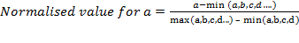 ...................... (2.2)

Similarly, if a,b,c,d... are their costs like initial cost then,

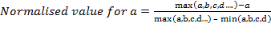 ....................... (2.3)

Such values are calculated for all a,b,c,d and thus these values form a value table row for that leaf node. All these rows combine to form the value table.

  - Calculation of Ranks
For calculation of ranks the weights for the leaf nodes need to be calculated. The weight of a leaf node is given by the product of the priority values of the leaf node and its predecessor node and the predecessor node of that node and so on until we reach the top level node. Let us understand the calculation of weights with the help of an example of the soap making technology [10]. Fig 2.3 gives the hierarchy tree for soap making technology decision. Let [a1 a2 a3 m1 m2 m3 m4] represent the priority vector of the pairwise comparison matrix of the main attributes A1, A2, A3, M1, M2, M3, and M4. In Level 2, the attributes A12, A13, A14, and A4 are pairwise compared with respect to their relative importance to M1 and their priority vector [a12 a13 al4 a4] is obtained. Similarly priority vectors [m5 a7 a9], [a11 a15] and [a8 a16] are obtained. In Levels 3 and 4 we obtain priority vectors [m6 a10] and [a6 a5]. Now the overall weights vector, [w1 w2... w16] for the attributes is arrived at by successively multiplying the attribute weights from Level 1 to Level 4. For example, w1, w2, and w3 are equal to al, a2 and a3, respectively; w12 is equal to a12 multiplied by m1. Similarly w6 is equal to a6*m6*m5*m2.
Now the task at hand is to calculate the ranks. The rank of an alternative is found by evaluating the rank values Rj for each alternative. The normalized values for the leaf node criteria are taken from the value table and the rank value for an alternative is found out by summing the multiplication of the normalized value of the alternative with respect to a leaf node with the weight of the leaf node. The rank value is calculated as:

........................................................ (2.4)

Where rank of jth alternative, is is the normalised value of the jth technological alternative with respect to the ith attribute. And is the weight of the ith leaf node.
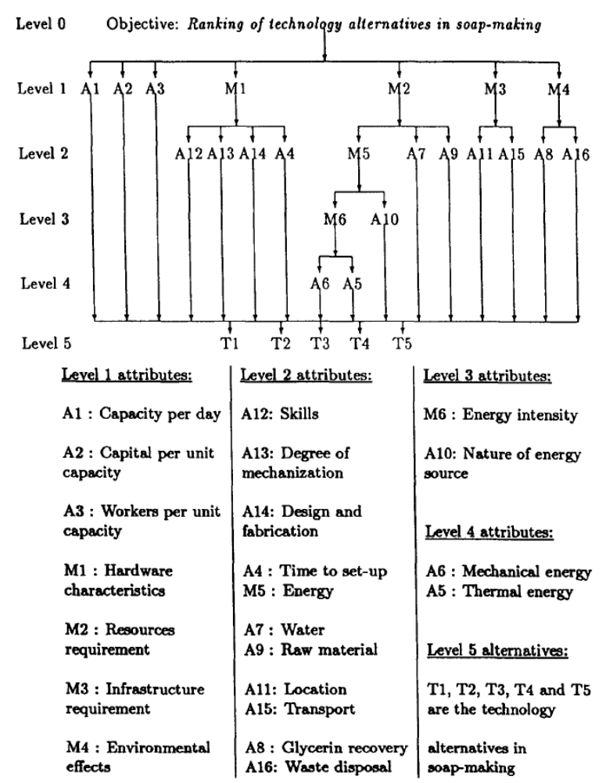
Fig2.3: Hierarchy Tree for Soap Making Technology decision [10]

  - Scope of AHP
Like all modelling methods, the AHP has strengths and weaknesses. In case of conflicting objectives AHP can rank choices in the order of their effectiveness. This is main advantage of the AHP. If the judgements made about the relative importance of the various factors are correct, then the AHP calculations lead to the logical consequence of those judgements. AHP can also detect inconsistent judgement.
It can be used for multi-criterion, multi-person problems. It can handle qualitative input.
AHP has an advantage that it can take into account decision making in presence of environmental, social and other influences. It can handle subjective judgements of individuals.
One seeming limitation is that wrong input will fetch wrong output. So only an expert or team of experts can handle wide range of criteria affecting a case under study. AHP can help you making a decision, but it has no intelligence of its own. The other seeming drawback is that if the scale is changed from 1 to 9 to, say, 1 to 29, the numbers in the end result, which we called the Normalized Eigen Vector (NEV), will also change. In many ways, that does not matter as the NEV simply says that something is relatively better than another at meeting some objective.
In short, the AHP is a useful technique for discriminating between competing options in the light of a range of objectives to be met. The calculations are not complex and, while the AHP relies on what might be seen as a mathematical trick, we don’t need to understand the maths to use it.
The various areas where AHP can be applied are listed below:
- Industrial Decisions: Decisions regarding choice of technology, choice of facility location, choice of software and investment options are typical problem instances of AHP because of the presence of both qualitative and quantitative factors.
- Government decisions: The government is faced with several decisions eg. selection of policy or schemes which are more beneficial. These can be evaluated using AHP.
- Agriculture: Let us take the example of selecting a land for setting up an agricultural farm. This decision would include factors such as soil fertility, availability of labour, cost of land, distance of farm from markets, availability of road network etc. and many sub factors also, thus making up a perfect instance for AHP.
- Similarly for general technology selection decision and investment option selection decisions AHP can be applied.
Date [12] has done characterization of technology alternatives in four technologies: namely soap-making, vegetable oil extraction, leather tanning, and water purification. Baron [13] has presented case studies on the choice of technologies in 11 food-processing industries with reference to their appropriateness for third world countries. Karmarkar [14], [15], [16] has characterized the alternatives in cement making, brick making, and rice milling. Xerox, British Columbia Ferries Management Reorganization at Edgewood, NASA, Choosing the Lunar Lander Propulsion System use AHP extensively for their operation and decision making [17]. The Xerox Corporation uses AHP for R&D decisions on portfolio management, technology implementation, and engineering design selection. AHP is also used to help make marketing decisions regarding market segment prioritization, product-market matching, and customer requirement structuring. To date, none of the major decisions made with AHP at Xerox have been overturned.

CHAPTER-3
OVERVIEW OF SOFTWARE FOR AHP
  - Introduction to Matlab package:
Matlab is numerical computing languages and have inbuilt functions to perform special calculations like eigenvalues, eigenvectors, the arithmetic mean, standard deviation, median, equation solutions, etc. When compared with traditional languages like C, C++, the program development and execution is easier. Package allows vector and matrix manipulations.
It is supported on windows 2000/XP/VISTA, Linux and several versions of UNIX, Mac OS X, etc. It has development tools like editor and code checker used to implement algorithms efficiently.

  - Earlier work on AHP package using Matlab and Scilab software
The Analytic Hierarchy Process was implemented in Matlab by Subba Raju [Raju U.S,
1995]. the package was implemented for qualitative attributes only and it was for multilevel.
Because of the change in versions of the Matlab software, the package developed is not executable on the current Matlab environment.
Bapuji, K. has made a code for AHP of qualitative and quantitative attributes in Matlab (for single level and multilevel) and Scilab (single level). It has limitations that first level can have only upto four criteria and each of them can be divided in at most four sub criteria. Any mistake in feeding input would cause all the earlier input to be in vain.
Various software found on internet are either paid or are for single level or don’t use eigen value method etc.
Therefore an attempt was made so that the new Matlab software for AHP can take required set of input from a file in a predefined format with no restriction of levels or no. of criteria. The code written in this was elegant in the sense that it is less 150 lines compared to earlier code of about 1000 lines. Unfortunately the bug in it is not removed and hence final rank calculation is not happening.

Matlab has to be installed on the computer for using a package developed in Matlab. In web application also, a case can be saved for future review or even for editing the value of attributes. Modules used in software are explained in chapter 4 with a Use Case.
The web application in Java and jsp (java server pages) is developed in Netbeans IDE. This choice naturally came as web application can be accessed by internet user and no extra software installation is required. Ubiquity of user is thus addressed. Netbeans was chosen as against its alternatives like eclipse and WebLogic. An integrated development environment (IDE) is a software application that has facilities like Source code editor Compiler and/or interpreter Build automation tools Debugger. Hence it is useful to computer programmers for software development.
WebLogic was giving an error (“page flow error”) for pages that are recursively called. Removal of bugs for was not possible and hence it was rejected.
Eclipse was rejected as any change in UI has to be manually fed in every other file wherever required. While developing code in NetBeans IDE, it was automatically done.

Earlier it was thought that even while developing web application for AHP, Matlab API will be used for doing matrix manipulations. Matlab has Java API. A Java program can call Matlab function using this. In that case Matlab was required only at the server and not at the client machine. But as it was found later, packages like JUNG, JAMA which are available in Java can do the required task.

JAMA is a basic linear algebra package for Java. It provides user-level classes for constructing and manipulating real, dense matrices. It is meant to provide sufficient functionality for routine problems, packaged in a way that is natural and understandable to non-experts. A straightforward public-domain reference implementation has been developed by the MathWorks and NIST.
JUNG — the Java Universal Network/Graph Framework--is a software library that provides a common and extendible language for the modelling, analysis, and visualization of data that can be represented as a graph or network. It is written in Java, which allows JUNG-based applications to make use of the extensive built-in capabilities of the Java API, as well as those of other existing third-party Java libraries.

Software Used
MatLab 6 or above
NetBeans Full Bundle 6.5.1 IDE
Tomcat 5.5
Java version 1.6
CHAPTER-4
IMPLEMENTATION
Efforts have been made in this package to make the AHP software as user friendly as possible. This also justifies the use of “JSP java script”. Because the AHP input consists of a lot of data and all or part of it may be repeated from the previous problem instance. Therefore, the drop down box options and other options on the front page to reload the previous data can be very useful for the user. Using the following test case, we now demonstrate the various functionalities and operations performed by our web-based AHP application, with the help of screenshots taken during the runtime of the presentation. Fig. 4.1 displays the welcome screen of the application named index.jsp.
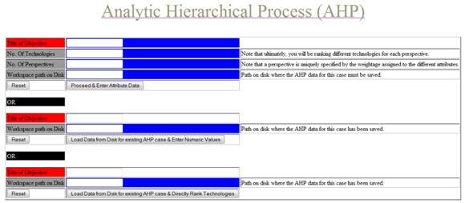
Fig. 4. 1: Welcome screen of the AHP software

Out of the 3 options provided to input data to the application, we demonstrate here the first option. Following inputs are then fed to the program as shown in Fig. 4.2.
- Title of Objective: Choosing a best car.
- No. of Technologies: 6
- No of perspectives: 1
- Workplace path on Disk: C:\Users\rajat\Desktop\
Here, in Title text box, a string input is expected, No. of Technologies and No. of perspectives expect an integer input, Workspace path on Disk is to be typed or at best copy pasted. There is no facility for browsing and selecting a location. The case under evaluation is saved here. If user wants to use a case which was already saved, next text box is to be filled, and workspace path of where the case is saved is to be manually entered. The program leads to a page where one can make use of hierarchy tree already saved and edit values for attributes. The tree structure cannot be changed and a quantitative attribute cannot be made qualitative or vice versa. No. of technologies cannot be changed. Though No. of perspectives cannot be changed, but by changing the input in the form of comparison matrix, and an attributes’ being cost or benefit, the perspective is changed. Workspace path on disk which is entered will be automatically generated if it does not exist. If the result of a saved case is to be seen again third text box for Workspace path on Disk is to be filled. Reset buttons are provided to clear the fields.
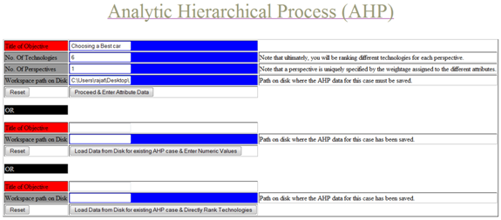
Fig. 4.2: Set of input being fed to the program

Out of the 3 options provided to input data to the application, we demonstrate here the first option. Following inputs are then fed to the program as shown in Fig.4.2.
- Title of Objective: Choosing a best car.
- No. of Technologies: 6
- No of perspectives: 1
- Workplace path on Disk: C:\Users\rajat\Desktop\

On proceeding, next page (page2.jsp) opens. In the first text box one has to enter No. of criteria in the first level of hierarchy tree. An integer input is expected. Otherwise HTTP Status 500 error report comes on next page. User can go back and re-enter value at page2.jsp.
On this page, Names of alternative technologies are expected to be entered. Number of text boxes created on this page equal “No. of technologies” entered on index.jsp page. There is default entry made for each technology as Technology 0, Technology 1 for Name of Technology No. 0, Name of Technology No. 1, and so on. It is expected that user enters the names but this of default names provision has been made for faster calculations. Note that, as of now, there is no provision for changing the names of technologies once we proceed. So it is highly recommended to enter the names. Same is true for Name of Perspective. Proceed button on the page saves the string inputs and opens page3 .jsp.
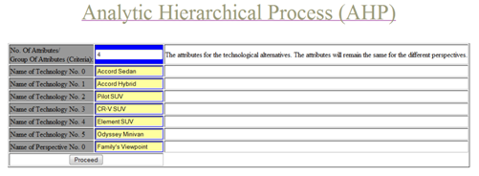
Fig. 4.3 Entering names of technological alternatives and perspectives

On page3.jsp, number of text boxes equal to the number entered in the first text box open. These are criteria at depth one or level one of hierarchy tree. The parent node of these attributes is seen so as to indicate it to user to remove any kind of ambiguity. Default names appear in the text boxes but names of these criteria are expected to be entered. In front of each criterion, an integer input is to be given to indicate in how many sub-criteria it is divided. A leaf node is either quantitative or qualitative. A radio button is to be clicked. Note that as this input cannot be changed later, it should be filled carefully. Input regarding one level is taken on this page.

This page is recursively called as many times as many depths are there in the hierarchy tree.
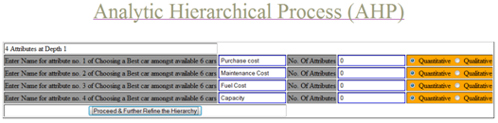
Fig. 4.4 Hierarchy Tree input

Next time the page opens, it will show number of attributes at depth 2 in first line, Then subsequent lines will have instructions to enter the name of attribute with the name of parent attribute and so on. This page is called on pressing proceed button until all the integer inputs are 0. This means there is no next level in hierarchy tree. User is expected to enter the names of nodes of trees, but it not compulsory. Default names appear in the text boxes as A:N_0_0, A:N_0_1 which indicate the position of node in the tree. For example, A:N_0_0 is first child of root node. A:N_0_1 is second child of root node. A:N_0_0_1_2 is third child of second child of first node in the level one of the hierarchy tree and so on.
On the next page (quanMatrixInput.jsp), input for all the leaf nodes which are marked quantitative is taken and with respect to each of the perspective whether it means cost or is benefit to user. Depending on the choice of cost or benefit, appropriate calculations are done on the arrays of input.
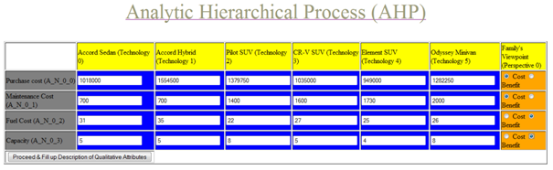
Fig. 4.5 Entering Quantitative Attributes

After the information about qualitative and quantitative attributes is entered, user is asked to feed comparative input for the sibling nodes of hierarchy tree. All comparisons are done on one page (quanMatrixInput.jsp). If there are more than one perspectives, then first, input for whole tree is taken for first perspective and then for the later. It asks only lower triangular entries in the matrix. Upper triangular entries are automatically generated using eqn (CHECK EQN). When the input is fed to the program, on pressing proceed button, same page shows λ_{max}, Consistency Index CI, and whether the input is accepted or not. If some comparisons are not accepted user has to enter only those entries and not the entire input. Another option to change Threshold value of CI is also there. CI < 0.1 is recommended. But in case user wants, Threshold value of CI can be made < 0.12 or so. Same is done for qualitative attributes on qualMatrixInput.jsp (screenshot not shown here) with only difference being comparison matrix input is taken for each qualitative attribute for each perspective with rows and columns being technological alternatives.

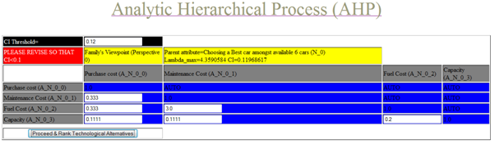
Fig.4.5: Comparison Matrix for sibling nodes of tree

Fig. 4.7 shows the screenshot when revision is accepted. It is shown by green colour. Also notice the upper triangular entries being computed and shown. The input has to be given in decimal form. 1/3, 1/5 is not accepted. Instead 0.333, 0.2 etc should be entered. Note that there is no possibility of showing upper triangular entries as soon as user enters the numbers in matrix. If AJAX technology is used, this can also be implemented.

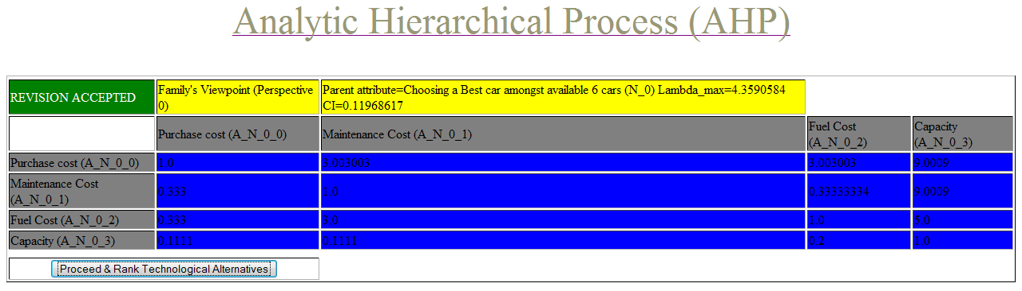
Fig. 4.7: Indication of acceptance of comparative input
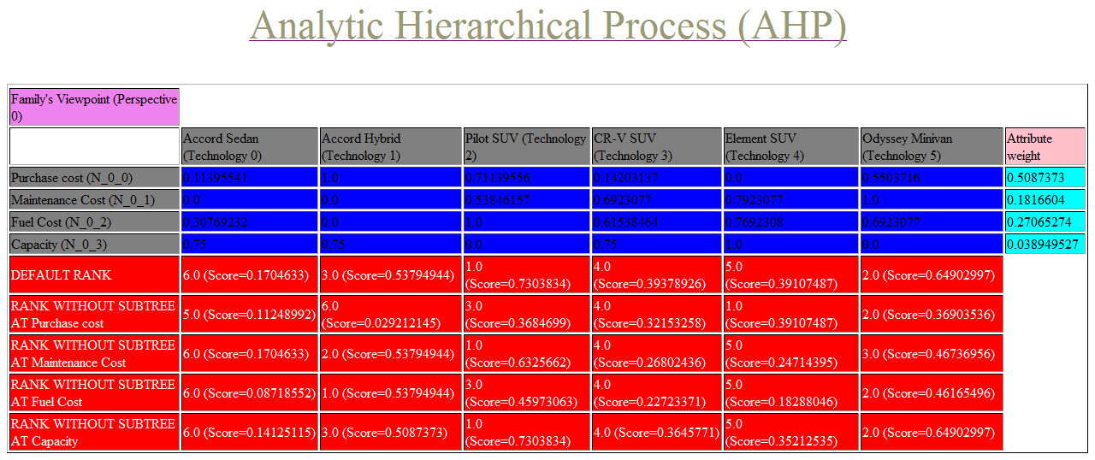
Fig. 4.8: Output page

On proceeding, user can see value table and Attribute weights as well as ranking of technological alternatives on page MatrixProcessing.jsp. Separate tables are generated for each perspective. Fig.4.8 shows one such table.

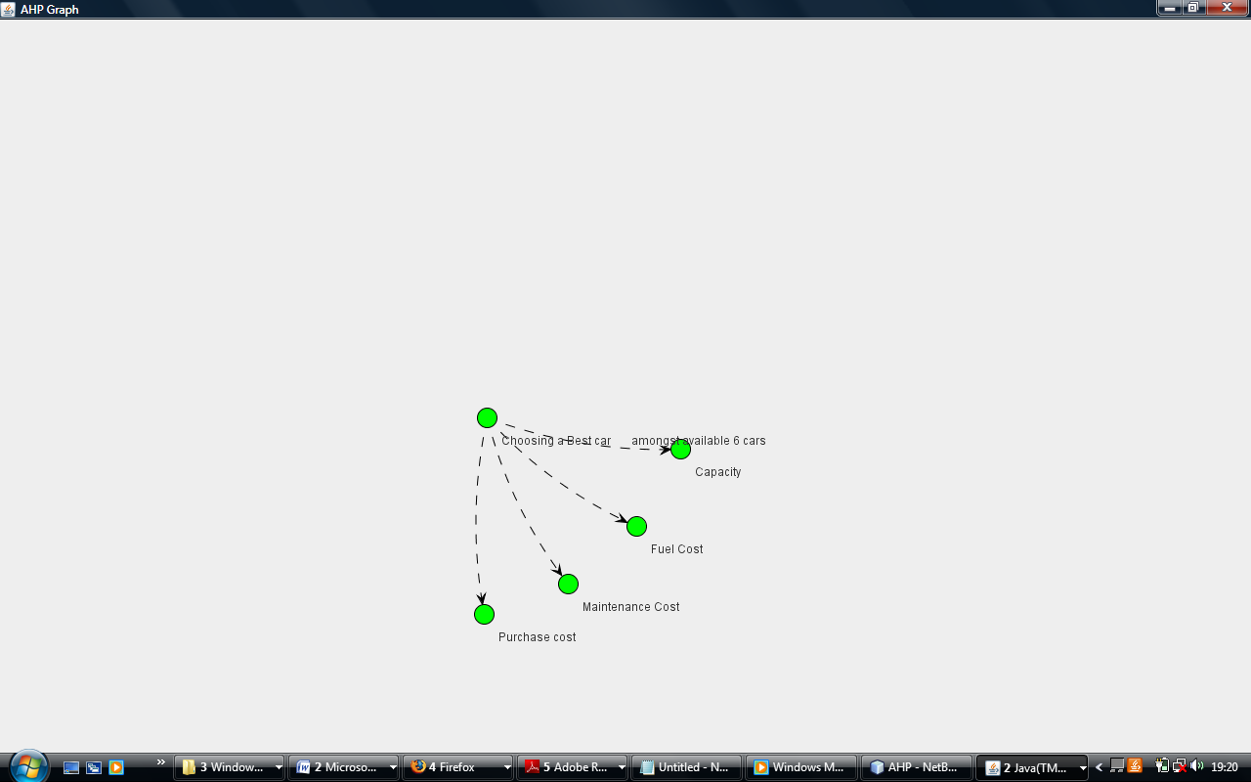Fig 4.9: Sample graph for tree structure

This program uses JUNG (Java Universal Network and Graph) package for mapping tree. It produces tree structure as shown in Fig.4.9.

CHAPTER-5
CONCLUSION AND FUTURE WORK
  - Conclusion
Although numerous organizations in both the private and public sectors have already benefited from the use of AHP, there are far more organisations still unaware of a process such as AHP that is theoretically sound, understandable, and matches their expectations. We hope that this project will help in making these organizations aware of a viable alternative to applying inferior common simplistic strategies to important decisions with the help of web based application of AHP which can be made accessible through internet.
Multilevel AHP is implemented a web application. Provisions such as editing the data entered for a case and saving a case in half way make it versatile. Multilevel AHP implementation in Matlab is near completion and features like input through file makes it better than earlier available programs.

  - Future work
Bug fixing: There is a reported bug in dynamic listing of a page which gives wrong results for normalization in case of quantitative attribute.
To display rank in bar chart on client machines
To draw a hierarchy tree in square form
Rank calculation command in Matlab is not taking place
To prepare user guide and a demo exercise

References:
  - http://www.scientificweb.com/ncrunch/ncrunch5.pdf last visited on 28/06/2009
  - http://www.hipre.hut.fi/ last visited on 28/06/2009
  - http://www.isc.senshu-u.ac.jp/~thc0456/EAHP/AHPweb.html last visited on 28/06/2009
  - http://www.cci-icc.gc.ca/tools/ahp/index_e.asp last visited on 28/06/2009
  - http://design.me.uic.edu/software/matlab/ahp/ last visited on 28/06/2009
  - http://people.revoledu.com/kardi/tutorial/AHP/index.html last visited on 20.06.2009 last visited on 28/06/2009
  - Saaty, T. L. (1994b).” Fundamentals of Decision Making”, RWS Publications, Pittsburgh, PA
  - Saaty, Thomas L. (2008). "Relative Measurement and its Generalization in Decision Making: Why Pairwise Comparisons are Central in Mathematics for the Measurement of Intangible Factors - The Analytic Hierarchy/Network Process", RACSAM (Review of the Royal Spanish Academy of Sciences, Series A, Mathematics) 102 (2): 251–318.
  - http://classweb.gmu.edu/rganesan/AHP.ppt last visited on 28/06/2009
  - U. Subba Raju, N. Rangaraj, and A. W. Date (1994). “The Influence of Development Perspectives on the Choice of Technology”, North Holland Publishers.
  - Saaty T L (1980). “The Analytic Hierarchy Process”, McGraw Hill International.
  - Date, A. W. (1980), “Comparison of Technological Alternatives in Some Products and Processes in India, UNITAR Project on Technology, Domestic Distribution and North-South Relations”, Report No. (CTR 34/80), ADS, Kashele, Maharashtra, India.
  - Baron, C. G.,( 1980),” Technology, Employment and Basic Needs in Food Processing in Developing Countries”, Pergamon Press, Oxford
  - Karmarkar, M. (1991), “An Evaluation of Cement-Making Technologies”, CTARA report, CTARA, IIT, Bombay.
  - Karmarkar, M. (1991),” Technology Evaluation of Brick-Making”, CTARA report, CTARA, IIT, Bombay.
  - Karmarkar, M. (1991),”Technology Evaluation of Rice-Milling”, CTARA report, CTARA, IIT, Bombay.
  - Forman , Ernest H. , Gass Saul I., “The Analytic Hierarchy Process – An Exposition”

